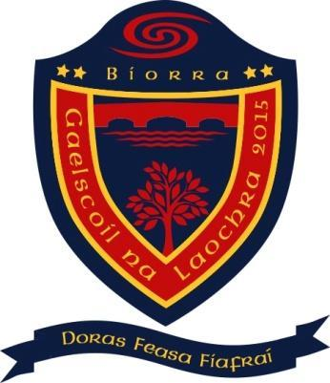
Gaelscoil na Laochra
Sandymount Haven
Biorra
Co. Uíbh Fhailí

Príomhoide: Niamh Uí Chléirigh

Uimhir Rolla: 20461B Ríomhphost: priomhoide@gaelscoilnalaochra.com Guthán: (057)9123876

Ráiteas Polasaí Scoile COVID-19
Tá Gaelscoil na Laochra tiomanta ionad oibre sláintiúil agus sábháilte dár bhfoireann ar fad agus timpeallacht foghlama shábháilte dár ndaltaí uile a chothú. Lena chinntiú, tá an Plean Freagartha COVID-19 seo a leanas forbartha agus nuashonraithe againn. Tá Bainistíocht agus foireann na scoile go léir freagrach as cur i bhfeidhm an plean seo agus cuideoidh iarracht comhchoiteanna le bac a chur ar scaipeadh an bhvíreas. Tá sé mar aidhm againn:
- leanúint ar aghaidh le monatóireacht a dhéanamh ar ár bhfreagra COVID-19 agus an plean seo a leasú i gcomhairle lenár bhfoireann
- eolas rídhéanaí maidir le treoracha shláinte poiblí an FSS agus Gov.ie a chur ar fáil dár bhfoireann agus daltaí
- eolas faoi comharthaí COVID-19 agus conas ba cheart do lámha a ní a thaispeáint
- ionadaí oibrithe a bhfuil furasta le aithint a aontú leis an bhfoireann chun an ról atá leagtha amach sa phlean seo a chomhlíonadh
- an fhoireann agus na daltaí go léir a chur ar an eolas faoi sláinteachas riachtanach maraon le béasaíocht anála agus riachtanais scaradh sóisialta
- an scoil a athchóiriú chun scaradh sóisialta a chur i bhfeidhm mar is oiriúnach le treoracha agus orduithe na Roinne Oideachais
- logleabhar teagmhála a choimeád chun chabhrú le rianú teagmhála
- cinntiú go rachaidh an fhoireann i dteagmháil leis an faisnéis ionduchtaithe / taithíocha a chur an Roinn Oideachais ar fáil
- an próiseas chomhaontaithe i gcás go mbeadh duine sa scoil ag taispeáint na comharthaí de COVID-19 agus iad ar scoil a chur i bhfeidhm
- treoracha a chur ar fáil don fhoireann agus dosna daltaí i gcás go bhfuil siad ag taispeáint na comharthaí de COVID-19 agus iad ar scoil
- glantóireacht a chloíonn le treoracha na Roinne Oideachais a dhéanamh
Rachfar i comhairliúchán leis an bhfoireann ar bhonn leantach agus fáiltítear aiseolas ar pé ábhar imní, fadhbanna nó moltaí.
Is féidir é seo a dhéanamh tríd an bPríomhionadaí (/-ithe) Oibrithe, a dtacófar leis/léi de réir an chomhaontaithe idir an Roinn agus na páirtithe oideachais.

Síniú: 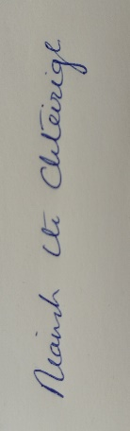 Dáta: Meán Fómhair 2021

COVID-19 Policy Statement
Gaelscoil na Laochra is committed to providing a safe and healthy workplace for all our staff and a safe learning environment for all our pupils. To ensure that, we have developed the following COVID-19 Response Plan. The BOM and all school staff are responsible for the implementation of this plan and a combined effort will help contain the spread of the virus. We will:
- continue to monitor our COVID-19 response and amend this plan in consultation with our staff
- provide up to date information to our staff and pupils on the Public Health advice issued by the HSE and Gov.ie
- display information on the signs and symptoms of COVID-19 and correct handwashing techniques
- agree with staff, a worker representative who is easily identifiable to carry out the role outlined in this plan
- inform all staff and pupils of essential hygiene and respiratory etiquette and physical distancing requirements
- adapt the school to facilitate physical distancing as appropriate in line with the guidance and direction of the Department of Education
- keep a contact log to help with contact tracing
- ensure staff engage with the induction / familiarisation briefing provided by the Department of Education
- implement the agreed procedures to be followed in the event of someone showing symptoms of COVID-19 while at school
- provide instructions for staff and pupils to follow if they develop signs and symptoms of COVID-19 during school time
- implement cleaning in line with Department of Education advice

All school staff will be consulted on an ongoing basis and feedback is encouraged on any concerns, issues or suggestions.
This can be done through the Lead Worker Representative(s), who will be supported in line with the agreement between the Department and education partners.

Signed: Date: Meán Fómhair 2021

